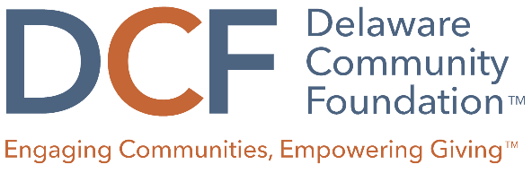

Capital Grant Evaluation Rubric
 | 5 (EXCELLENT) | 3 (AVERAGE) | 1 (POOR)
Organizational Need | Description is focused, realistic, and measurable. Proposal demonstrates strong case for how the project aligns with the organization’s mission. | Description lacks clarity or is somewhat unreasonable given the scope of the project. Proposal lacks sufficient information about how the project aligns with the organization’s mission. | Proposal lacks any description or evidence of how the project aligns with the organization’s mission.
Community Impact | The project design is clearly and thoughtfully described and addresses a defined community need, as well as how the project will increase opportunities to thrive. Intended outcomes are how they will be measured is well articulated. | Some elements of the project are not clear. There is limited description of the need and barriers faced by the community, and how the project will increase opportunities to thrive. Outcomes and how success will be measured is not entirely clear. | The project design is confusing and poorly described. The project appears to be outside the organization’s scope of work. The project design does not mention needs or barriers faced by the community. Lacks description of outcomes and how success will be measured.
Funding Request | A clear and reasonable project budget is included. Organization demonstrates a thoughtful approach to projecting expenses related to the project, and is seeking an appropriate mix of grant funding from other sources. | Project budget could be more cost-effective or detailed. Scale of project would require funding beyond the DCF, but no other funding sources are identified. | Budget figures are incomplete and/or unreasonable. No other funding sources are being sought or identified. There are concerns about organizational capacity or its ability to successfully complete the project.

