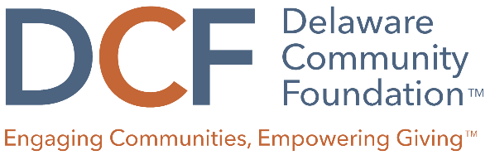

Specific Interest Grant Evaluation Scoring Rubric
 | 5 (EXCELLENT) | 3 (AVERAGE) | 1 (POOR)
Program Alignment | Program clearly aligns with grant guidelines. Proposal makes a very clear and compelling case about why the program is necessary and who will benefit. | Program is loosely aligned with grant guidelines. Vague description of community need and who will benefit. | Program does not align with grant guidelines. Doesn’t provide description of or data related to local community need.
Program Design | The program design is clearly and thoughtfully described and addresses the identified need, barriers faced by the community, and how the program will increase opportunities to thrive. The population to be served is specific and fully described. The program design is evidenced-based, best practice, or innovative. | Some elements of the program design are not clear. Proposal has a vague description of program details and of the population to be served. There is limited understanding of the need and barriers faced by the community, and how the program will increase opportunities to thrive. | The program design is confusing and poorly described. The population served is omitted or not related to the need. The program appears to be outside the organization’s scope of work. The program design does not mention needs or barriers faced by the community.
Organizational Capacity/Funding Request | Organizational financial health and potential for long-term sustainability are strong. The organization has required capacity to complete the program and demonstrates a track record of success. A clear and reasonable program budget is included, and is seeking an appropriate mix of grant funding from other sources. | Application presents vague information on organizational financial health and long-term sustainability. Applicant presented incomplete detail related to need for DCF funding. Scale of program would require funding beyond the DCF, but no other funding sources are identified. Program budget could be more cost-effective. | Application lacks information on overall financial health and long-term sustainability of organization. There are concerns about organizational capacity or its ability to successfully complete the program. Budget figures are incomplete and/or unreasonable.
Community Impact | Impact is focused, realistic, and measurable. Proposal demonstrates strong case for how the program will benefit the community. Outcomes are well-articulated and specific plans for measuring the outcomes and outputs are well thought-out, practical and provide meaningful data. | Impact lacks clarity or is somewhat unreasonable given the scope of the program. Proposal lacks sufficient information about how the program will benefit the community. Outcomes are vaguely defined, and specific plans to track outcomes and outputs are insufficient. The specific activities and timing are vague. | Proposal lacks any description or evidence of how the program will benefit the community. Program does not have clearly stated goals or outcomes, and lacks specific activities or clear methods of measurement to track success.

