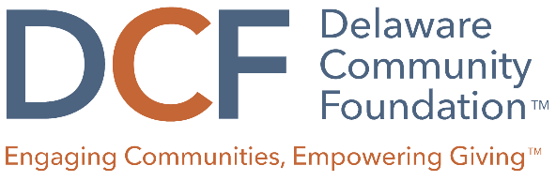

YPB Grant Evaluation Rubric
 | 5 (EXCELLENT) | 3 (AVERAGE) | 1 (POOR)
Program Description | Description is focused, realistic, and measurable. Proposal demonstrates strong case for how it fits with the YPBs focus statement | Description lacks clarity or is somewhat unreasonable given the scope of the project. Proposal lacks sufficient information about how it fits with the YPBs focus statement. | Proposal lacks any description or evidence of how it fits with the YPBs focus statement
Impact/Outcomes | The project design is clearly and thoughtfully described and addresses a defined community need. Intended outcomes are realistic for grant year. | Some elements of the project are not clear. There is limited description of the need and barriers faced by the community. Intended outcomes are not realistic for grant year. | The project design is confusing and poorly described. The project design does not mention needs or barriers faced by the community. Lacks description of outcomes and no description of how they will be accomplished in grant year.
Funding Request | A clear and reasonable project budget is included. Organization demonstrates a thoughtful approach to projecting expenses and how YPB dollars will be used, and is seeking an appropriate mix of grant funding from other sources. | Project budget could be more cost-effective or detailed. Scale of project would require funding beyond the DCF, but no other funding sources are identified. | Budget figures are incomplete and/or unreasonable. No other funding sources are being sought or identified. There are concerns about organizational capacity or its ability to successfully complete the project.

