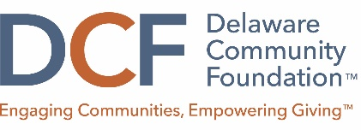
Guidelines for the Specific Interest Grants at the Delaware Community Foundation.

There are a variety of funds at the DCF that provide a structured opportunity for eligible nonprofits whose missions align with specific interest areas to apply for grants. These specific areas include:
- Small grants for arts in Wilmington
- Fulfillment of terminally ill children’s wishes
- Support animals and animal welfare
Small Grants for Arts in Wilmington
Made possible through the Dave Ryerson Fund and the Beekhuis Community Fund at the DCF, these small grants will support charitable organizations that support the arts throughout Delaware. The opportunity is designed for small organizations or larger organizations with smaller, discrete projects. Supported programs include the presentation of performing, visual, literary, media or folk arts in communities throughout Delaware, and that reach audiences and participants with limited access to the arts or to a particular art form.
Awards will range from $1,000 to 2,500.
Fulfillment of Terminally Ill Children’s Wishes
Made possible through the Walls & Turner Charitable Fund at the DCF, these grants will support charitable organizations that:
- Grant the dreams and wishes of chronically and terminally ill children of families with limited financial resources in Delaware
- Grant the dreams and wishes of chronically and terminally parents with children in Delaware who do not have the financial resources for sharing a dream or wish with their children before their expected deaths
Awards will range from $2,500 to $7,500.
Support Animals and Animal Welfare
Made possible through the Walls & Turner Charitable Fund and the Freida Dolby Fund at the DCF, these grants will support charitable organizations that:
- Assist in the training of professionally trained seeing eye dogs and service assistance dogs for blind individuals, deaf individuals and/or individuals with mobility impairments and/or other physical disabilities
- Provide support services in connection with the placements of such dogs with eligible recipients who are residents of the State of Delaware who demonstrate a drive to become more independent and who would not be able to acquire such dogs without financial assistance
- Encourage the humane treatment of animals in Delaware through education of the public, adoption of animals without owners, neutering, and enforcement of laws governing the humane treatment of animals.
Awards will range from $2,500 to $7,500.

